## What is the LOOKUP Function?

The LOOKUP Function is categorized under Excel Lookup and Reference functions. The function performs a rough match lookup either in a one-row or one-column range and returns the corresponding value from another one-row or one-column range.  
**There are mainly 3 Types of Lookup Function**

### **1) LOOKUP function**

The LOOKUP function in Excel can perform the simplest types of vertical and horizontal lookups.

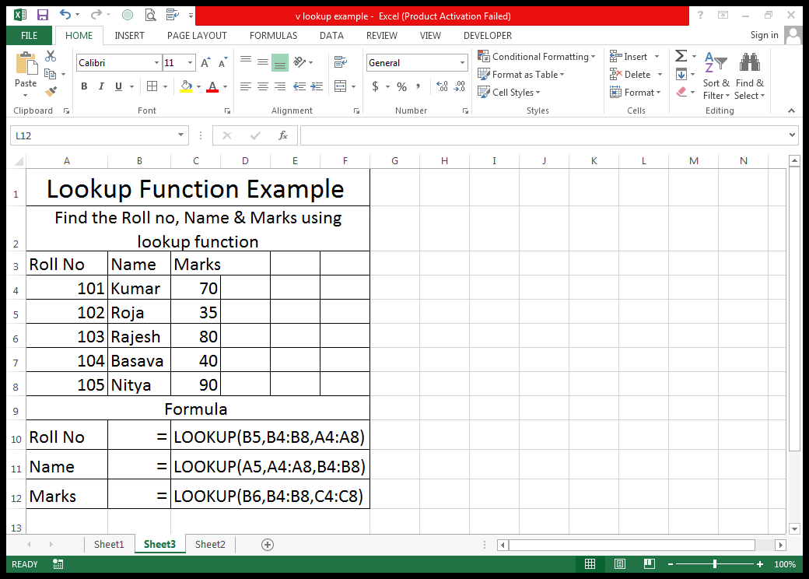

**2) VLOOKUP function is** an improved version of the LOOKUP function specially designed to do **vertical lookup** in columns. TRUE – Approximate match - FALSE – Exact match

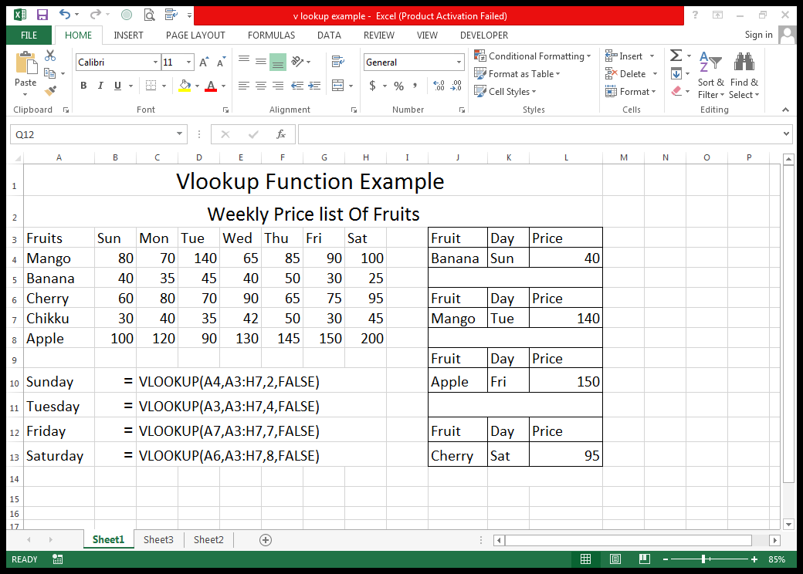

**Price**

**Formula**

### **HLOOKUP function**

It's a **Horizontal** counterpart of VLOOKUP that searches for a value in the first row of the lookup table and returns the value in the same position from another row.

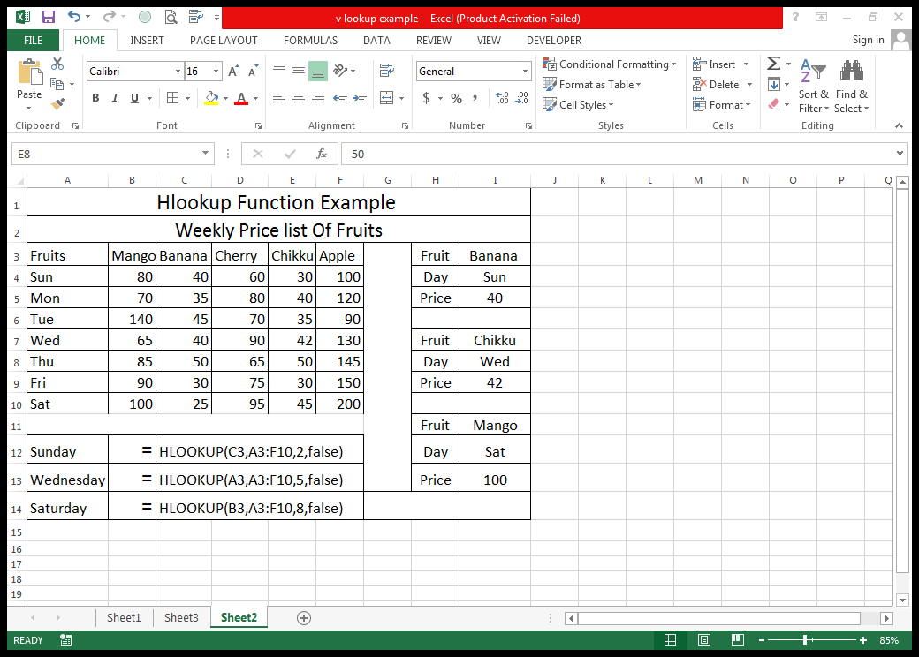

**Price**

**Formula**

PivotTable

A PivotTable is **a powerful tool to calculate, summarize, and analyze data that lets you see comparisons, patterns, and trends in your data**

